REBELLION
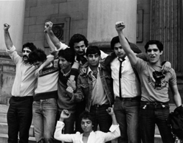
A documentary feature film

Instagram: @migrantmedia
Instagram: @therebellionfilm
Email: bradford12film@gmail.com
Website: www.rebellionfilm.org
Stills download: https://we.tl/t-JogZ8rcKG3Aw3zZs
Trailer download: https://vimeo.com/migrantmedia/rebelliontrailer

Title: Rebellion

Logline: Self Defence and the story of the Bradford 12

25 word synopsis:

In 1981 twelve young Asian men were charged with terrorism for defending Bradford from racist attacks. Their acquittal established the right of self-defence.

50 word synopsis:

In 1981, people of Bradford organised to stop violent racist skinheads. Twelve Asian youth were charged with terrorism for defending their community. Thousands rallied in protest, demanding justice. The case of the Bradford 12 became a defining moment for collective anti-racist resistance and exposed deep injustices in the UK.

75 word synopsis:

In 1981, twelve young Asian men in Bradford were charged with terrorism for defending their community against a violent racist skinhead attack. Known as the Bradford 12, their arrest sparked fierce national and international protests, shining a harsh light on Britain’s racial tensions. After a tense, drawn-out trial, they were acquitted—setting a powerful legal precedent for organised armed self-defence. Their courage stands as a lasting symbol of resistance against injustice in the UK.

100 words

In 1981, twelve young Asian men in Bradford faced terrorism charges after defending their community from a violent racist skinhead attack. They made petrol bombs for self-defence. The ‘Bradford 12’ had armed themselves to take direct action against fascist violence.Their case exposed the intense racial tensions in Britain. Their arrest sparked fierce protests nationally and internationally, with thousands demanding justice for the Bradford 12.Ultimately, they were acquitted—a landmark victory affirming the right to organised armed self-defence for oppressed communities. Their courage and solidarity challenged systemic racism and continue to inspire the fight for justice.

150 word synopsis:

In 1981, twelve young Asian men in Bradford faced terrorism charges after defending their community from a violent racist skinhead attack. They made petrol bombs for self-defence. Known as the Bradford 12, by arming themselves, they took direct action to ward off the greater threat of skinhead violence. The state labelled them terrorists, but the people rallied behind the slogan, “Self-defence is no offence.”
Their case exposed the intense racial tensions in Britain. Their arrest sparked fierce protests nationally and internationally, with thousands demanding justice for the Bradford 12. The lengthy, tense trial revealed a police force indifferent to racist violence, one that believed discrimination was necessary and had Special Branch surveillance on key defendants.
Ultimately, the Bradford 12 were acquitted—a landmark victory affirming the right to organised armed self-defence for oppressed communities. Their courage and solidarity challenged systemic racism and continue to inspire the fight for justice.

500 word film outline:

Rebellion frames the fight for justice for the Bradford 12 as an epic documentary that captures not only the essence of this era, but speaks to the present as a testament to the collective will of those who would not let injustice be the norm. The film charts the years which gave birth to the Bradford 12, as much as their actions which led them to prison and trial. It is as much a story of Asians as it is of Afro-Caribbeans who suddenly found themselves facing the flames of racist violence. We hear from mothers of the 1980s, terrified of the attacks on their children; we hear from African men who reflect on the violence their ancestors endured, welded into a tense narrative with the stories of those who became the Bradford 12 and those who fought for their freedom—voices that resonate even more strongly today with the rise of British racism.
The era of the Bradford 12 was the era of racist gangs, of “Paki-bashers.” It was also a time when the defendants and their supporters were enraged by injustices overseas, especially in Apartheid South Africa, Palestine, and Northern Ireland. Through their story we are taken back into a world where there were dreams of a better and more just future—a human future full of hope. Yet it was also a world where hope itself had to be fought for with every breath.
The narration of the story is at once poetic, shaped by the voices of those who could no longer endure degradation and who demanded change. It is a journey into the symbols of the time, animated and blended into an archival record that speaks to coming generations.
The words of the Bradford 12, and of those who stood with them, rise again as both warning and call. They remind us of the dangers of ignoring the lessons of the past, but also sound a trumpet to stand up and reject the masters of this world and their vision of injustice. Instead, they urge us to fight for a better world—one rooted not in fear, but in dignity and hope.

800 word directors statement:

Ken Fero: The story of this production for me began on March 2, 1981. I was a 20 year old student at Camberwell School of Arts in South London. On that rainy morning I was smoking a cigarette outside the building when I heard rumbling that I thought was thunder, this soon grew closer and closer into what were the sounds of protest. First in ones and two’s, then in groups, then in thousands I saw and heard the demonstration for the Black People’s Day of Action. The slogans were compelling, the anger was palpable and I joined the march into central London. This was the moment of my political awakening.

It was ten years later, in 1991, after setting up Migrant Media - a radical film collective with a focus on resistance - that the Black People’s Day of Action reentered my life. I was making a documentary with Mogniss Abdallah called ‘Britain’s Black Legacy’ and needed archive film of stories of Black struggles, Menalik Shabazz, the legendary director who had documented the demonstration in the seminal ‘Blood Ah Go Run’ , came into our frame. We were also focusing on stories of resistance such as the Mangrove 9 and the Newham 7, which were well known. Coming across the story of the Bradfords 12 I was astounded at how little coverage it had gotten, given the importance of the victory of the 12, and met Mukhtar Dar who had been a central campaigner in anti-racist struggles in the North as well as Tariq Mehmood one of the key defendants. We discussed the possibility of making a film about the Bradford 12, it has taken 30 years to do so but the advantage of time is that it allows you space for poetical reflection and the freedom of political analysis based on lived struggles of resistance.

‘Rebellion’ was made collectively by a group of documentary makers and activists, many of whom were central figures in the Bradford 12, as well as those who supported them. The forensic archival nature of the film has been made possible through private collections as well as the generosity of the Yorkshire Film Archive. Beyond that ‘Rebellion’ teems with exclusive interviews and an epic reconstruction of the trial organised as a Third Cinema event where members of the Bradford 12, as well their children and community volunteers, recreated key moments of the trial. In doing so we rejected conventional drama to create powerful imaginative realism based on radical intergenerational lived experience of struggle. This is not just a political film, it has also been made politically.
Tariq Mehmood: What landed me in prison was the simple fact that I had grown up in Britain and had to fight for my very existence—at school, and on the streets. My dignity was buried beneath a racist curriculum where the colonised peoples of the world were either invisible or reduced to serving the myths of empire and white supremacy. Outside the classroom, the streets echoed with racist and far-right violence. Drunken gangs hunted us after the pubs closed; fascist organisations marched through the ghettos where we lived, shouting for “repatriation.”
As we finished this film, I was struck by how much has returned. The streets of Britain now witness the steady rise of the same kind of violence I grew up with. Yet there is also a profound difference. Back then, the far right was always outnumbered by anti-racists. White workers stood with us against the fascists, even when the flags of St George were paraded on the 23rd of April. It is a far cry from today, when hundreds of thousands have rallied behind a new nationalism. The language has shifted—“repatriation” has become “remigration,” and slogans like “send them back” or “we want our country back” have entered the popular lexicon—but the poison remains the same.
This film is about, not only how a community fought for its humanity, but about an era where this was the only choice, where national and international progressive forces came out in our defence. This film is both a testament to that struggle and a warning. It carries the voices of those who refused to bow to racism, who demanded justice even when branded criminals, and who transformed fear into resistance. Coming out in the glare of the Palestinian genocide, it is a warning against complacency, where silence is criminal.
Rebellion is not simply about remembering. It is about arming the future with the lessons of the past. It insists that history is not an archive to be left untouched, but a weapon to be used in the fight against the emerging menace of fascism.
For me, this film is personal. It has taken me 40 years to tell it, and it is a story of the wounds of my own life, in the scars of my generation, and in the courage of those who stood with us. But it is also universal: a call to resist, to organise, and to build a future where human dignity cannot be denied.

80 word directors bio (x 2)

Tariq Mehmood is the co-director of Rebellion, a documentary on the Bradford 12 case, in which he was a defendant and successfully defended himself. He is a novelist and political activist based between Manchester and Beirut, and an Associate Professor at the American University of Beirut. He previously co-directed Injustice with Ken Fero through Migrant Media, and is editor of Lines of Fire: Poetry of the Afro-Asian Writers Movement, co-published by Daraja Press and AUB.

Ken Fero is a filmmaker, activist and educator who with Migrant Media has produced several hard-hitting documentaries for over 40 years examining community responses to issues of race, class and resistance for national and international broadcasters as well as cinema. He is internationally renowned for the multi-award winning radical films Injustice (2001) and Ultraviolence (2020) and is a published author. He was a founding member of the United Families & Friends Campaign and is co-convener of the People’s Tribunal on Police Killings. www. vimeo.com/migrantmedia

Ken Fero Filmography:

2020 ULTRAVIOLENCE (75 minutes/UK/Migrant Media)
Winner - Best Documentary Silver Latitude Awards 2020. Special Jury Award - Queens World Film Festival 2021.
Special Audience Award - Arbetar Film Festival 2021.

2014 BURN (30 minutes/UK/Migrant Media)

2013 POPO (25 minutes/UK/Migrant Media).

2012 WHO POLICES THE POLICE (52 minutes/UK/Migrant Media)

2011 NEWSPEAK (25minutes/PressTV)

2011 DEFEAT OF THE CHAMPION (25minutes/PressTV)

2001 INJUSTICE (98 minutes/Migrant Media)
Winner Best Documentary - BFM London Film Festival 2002. Winner National Social Justice Award 2003. Winner Best Documentary (Human Rights) - One World Film Festival 2003.

1995 JUSTICE DENIED (52minutes/Channel 4 TV)

1994 TASTING FREEDOM (52minutes/Channel 4 TV)

1992 SWEET FRANCE (52minutes/Channel 4 TV)
Winner Mentione Speciale Images du Monde Arabe and Milano Province Prize 5th Festival of African Cinema.

1992 AFTER THE STORM (25minutes/BBC TV)

1991 BRITAIN’S BLACK LEGACY (45minutes/FR3TV)

1991 GERMANY – THE OTHER STORY (30minutes/FR3TV)
Winner Platform Europe Award.

Rebellion - Credit List

Rebellion
a film by
Ken Fero & Tariq Mehmood

Editorial Consultants
Jayesh Amin
Ishaq Kazi

Director of Photography
Soulyeman Garcia

Additional Camera
Koutiba D Salman

Sound Recordists
Kayla Marie Troy
Mira Pharaon
Amifel Cliff-Eribo

On-Line Editor
Stephen Morris

Narrator
Taj Atwal

Production Assistants
Magadalena Olcott
Luca Fero
Mia Collins
Maqsood Zulfiqar Zaman
Hamish Harris
Jonna Stendahl
Shareef Garcia

Make Up Artists and Costume
Ruth Elopuro
Mara Giovanna Bueno
Iris Harris

Animator
Yasmine Djedje Fisher Azoume

Music
Fun Da Mental

Ja Shataan
Written by H N Qureshi (Aki Nawaz)
Published QFM/Warner Chapell

Dog Tribe
Written by H N Qureshi (Aki Nawaz)
Published QFM/Warner Chapell

Fire Water
Written by Aki Nawaz and Mighty Zulu Nation
Published by QFM/Warner Chapell

President Propaganda
Written by H N Qureshi (Aki Nawaz)
Published by QFM/Warner Chapell

Courtesy of Nation Records

Additional Creative Commons Sound Effects

Gatwick Airport waiting area crowd noise and announcementby andriiperevodchyk
https://freesound.org/s/340276

Old trafford.wav by BeeProductive
https://freesound.org/s/430020/

Quiet Street BKK night by Salomé_Lubczanski
https://freesound.org/s/733843/

Very Busy Bar by richwise
https://freesound.org/s/497421/

Producer Court Room Scene
Fawzia Mahmood

Cast Court Room Scene
Bradford 12
Rajveer Singh Dogra
Kaan Heath
Waris Mehmood
Abdul Tanveer Rashid
Subhan Ahmed
Asad Qureshi
Neroshan Jayakumar
Emir Kuliev
Vikas Gogana
Miles Moss
Jamal Awar

Judge
John Forde

Police Officers
William Harris
Max Farrar

Barristers
Joseph Maggs
Naz Mahmoudzadeh
Hannah Millar
Tanzil Chowdhury
Caitlin Mettle
Patrick Davies
Aislinn Evans

Expert Witness
John Tranter

Jury
Charlotte Cotton
Katharina Schwarz
Caitlin Young
Fahim Qureshi
Zobia Haq
Yasmyn Nettie
Corinna Riva
Stephen Morris
Mara Bueno
Magda Olcott

Campaigners
Rajesh Patel
Lina Patel
Farah Ahmed
Monna Matharu
Matloub Husayn-Ali-Khan
Shalina Patel
Salim Rashid
Chandani Amin
Ruth Bundy
Satnam Gill
Onyeka Igwe
Ali Zaydi
Anya Nanning Ramamurthy
Ifrana Wahid
Charlie Scofield
Aymen Joseph
Joe Joseph
Kitty Carr
Virinder Singh
Farhana Uddin
Safiyyah Shazad
Oscar Russell
Will Hassani
Abby Bettridge
Marie Thorseth Molnes
Clemence Le Cour Grandmaison
Giada Scalisi
Raj Gupta
Azfar Shafi

Cast Molotov Scene
Tyreek Edwards
Dennis Fofanah

News Presenter Voice
Andy Greenhalgh

News Voiceover Sound Recordist
Jack Tomkins

Facilities
Silkwood Studio
Karamel N22
Wood Green Films
Town Hall Hotel
Fitzrovia Post
Costume Studios
Ideaplus Post Production
Video-Craft
ON8mil
Westpoint Television
Arc Blue Creative

Film Archive
Mukhtar Dar
Raj Gupta
Getty Images
'Brixton Riots' ITN via Getty Images
'Bloody Sunday' ITN via Getty Images
'Century Cinema Southall' ITN via Getty Images
'Gurdip Singh Chaggar Funeral' ITN via Getty Images
'Bengalis demonstrate Against NF' ITN via Getty Images
'London March Against Racist Attacks' ITN via Getty Images
'Margaret Thatcher in Manchester: Immigration' ITN via Getty Images
'National Front Counter Demonstrators' ITN via Getty Images
'Popular Front for the Liberation of Palestine spokesman' NBC News Archives via Getty Images
ITV Archive
Yorkshire and North East Film Archive
BBC Motion Gallery
Migrant Media
Excerpt from 'Blood Ah Go Run' by Menalik Shabazz
with kind permission of the Shabazz family

Stills Archive
Mukhtar Dar
Professor Augustine John
Max Farrar
Matthew Davison
Amrit Wilson
Jayesh Amin
Ishaq Kazi
Raju Bhatt
Celia Stubbs
Shahnaz Ali
Tandana
The Fincher Files
Popperfoto
Anna Singh
Ruth Bundey
Natasha Patel
Anaaya Patel

Insurance
Media Insurance Brokers

Legal
Siddharth Sangameswaran
Bindmans

Executive Producer
Shanida Scotland

BFI Doc Society Fund

Head of Fund
Luke W Moody

Senior Film and Production Executive
Hannah Bush Bailey

Head of Business Affairs
Suzanne Alizart

Production Manager
Kit Colbourne

Doc Society Director
Sandra Whipham

Special Thanks
Graham Relton
Aki Nawaz
Costume Studio Limited
Manoj Ambasna
Collage Arts
Anandi Ramamurthy
Sameena Hussain
Suhaiymah Manzoor-Khan
Dusty Rhodes
Lloyd Gardner
Khemi Shabazz
Tom Levin
David Dean
Institute of Race Relations
Sue Terry Voices

Made with the support of the BFI Doc Society Fund

© Black Resistance 2026

PRESS RELEASE
Rebellion - a documentary about self-defence and the story of the Bradford 12.

In 1981, twelve young Asian men in Bradford were charged with terrorism for bravely defending their community against a violent racist skinhead attack. Known as the Bradford 12, their arrest sparked fierce national and international protests, shining a harsh light on Britain’s racial tensions. After a tense, drawn-out trial, they were acquitted—setting a powerful legal precedent for organised armed self-defence. Rebellion is a testament to their courage, a lasting symbol of resistance against racial injustice in the UK.
Co-director Ken Fero said, "Rebellion is being released at a time when the conditions that made resistance to the far right unavoidable in 1981, are once again smashing down our doors. "
Rebellion frames the fight for justice for the Bradford 12 as an epic documentary that captures not only the essence of this era, but speaks to the present as a testament to the collective will of those who would not let injustice be the norm. The film charts the years which gave birth to the Bradford 12, as much as their actions which led them to prison and trial. It is as much a story of Asians as it is of Afro-Caribbeans who were facing the flames of racist violence. We hear from mothers, terrified of the attacks on their children; we hear from the Black communitywho reflect on the violence and resistance t, welded into a tense narrative with the stories of those who became the Bradford 12 and those who fought for their freedom—voices that resonate even more strongly today with the rise of British racism.
Co-director Tariq Mehmood, who was one of the central defendants in the case of the Bradford 12, says, "British streets are seething with pent up racist anger. The Far Right is no longer a fringe movement; if ever there was a time to learn from the past, it is now."
The era of the Bradford 12 was the era of racist gangs, of “Paki-bashers.” It was also a time when the defendants and their supporters were enraged by injustices overseas, especially in Apartheid South Africa, Palestine, and the North of Ireland. Through their story we are taken back into a world where there were dreams of a better and more just future—a human future full of hope. Yet it was also a world where hope itself had to be fought for with every breath.
The narration of the story is poetic, shaped by the voices of those who could no longer endure degradation and who demanded change. It is a journey into the symbols of the time, animated and blended with a rich archival record that speaks to coming generations.
The words of the Bradford 12, and of those who stood with them, rise again as both a warning and a call. They remind us of the dangers of ignoring the lessons of the past, but also sound a trumpet to stand up and reject the oppressors of this world and their vision of injustice. Instead, the film urges us to fight for a better world—one rooted not in fear, but in dignity and hope.

Rebellion was made with the support of the BFI Doc Society Fund
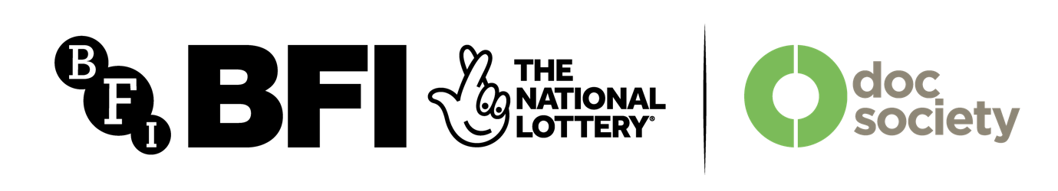
Ends

Download of hi res files: https://we.tl/t-JogZ8rcKG3Aw3zZs
Please note credits.

1-3 ©migrant media/ishaq kazi
4-8 ©migrant media/max farrar

- Bradford 12 Leeds Crown Court July 12 1982

- Bradford 12 Leeds Crown Court July 12 1982
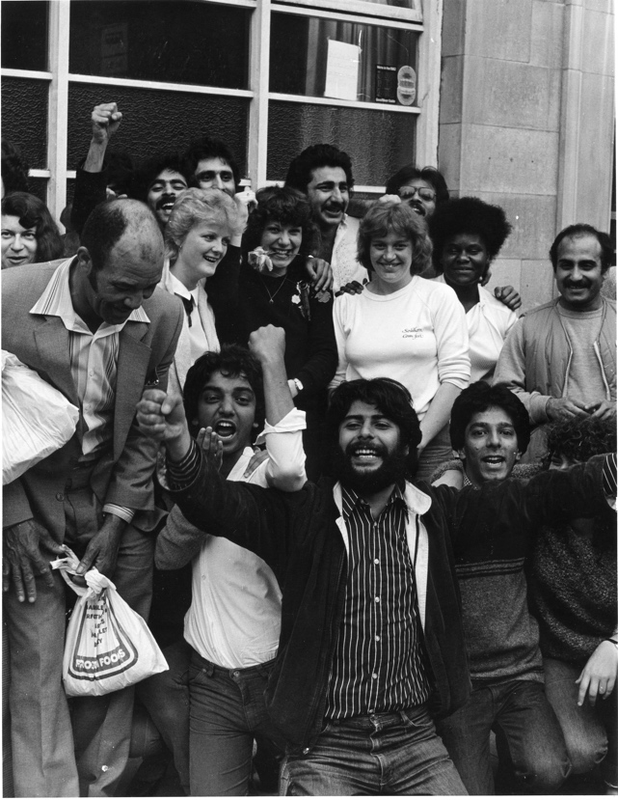
- Bradford 12 and Jury Leeds Crown Court July 12 1982

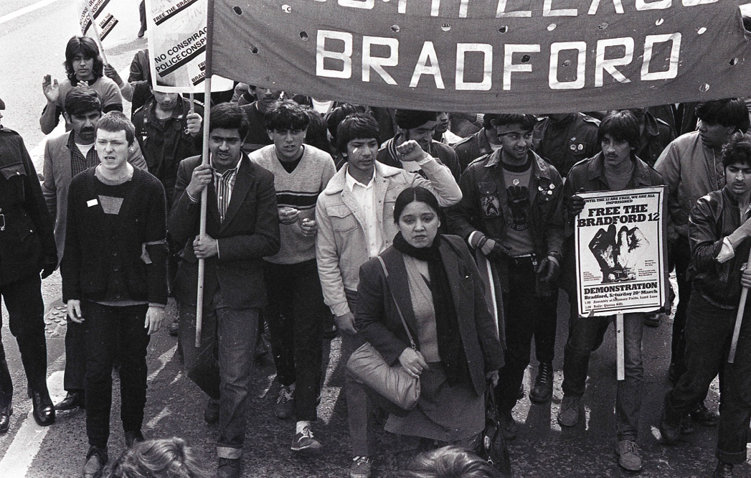
- Free the Bradford 12 demonstration Leeds April 3 1982

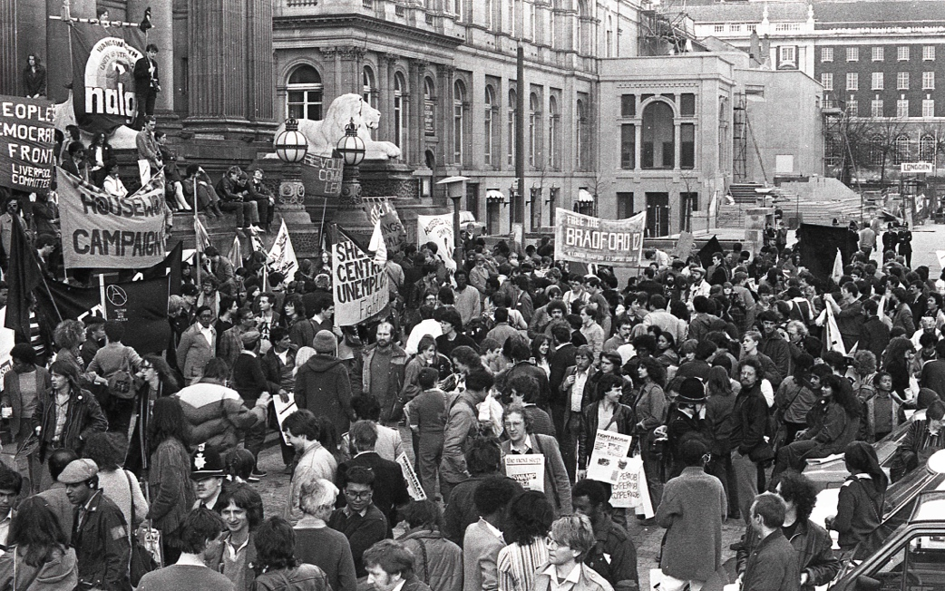
- Free the Bradford 12 demonstration Leeds April 3 1982

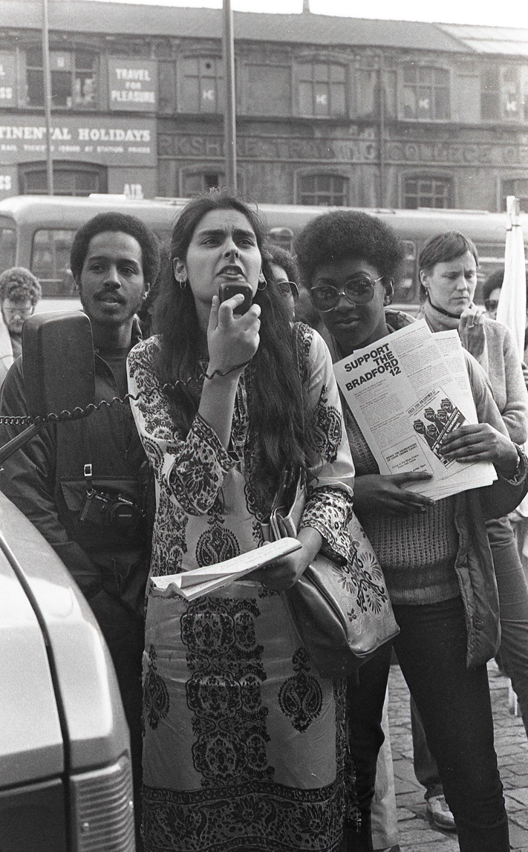
6. Free the Bradford 12 demonstration Leeds April 3 1982

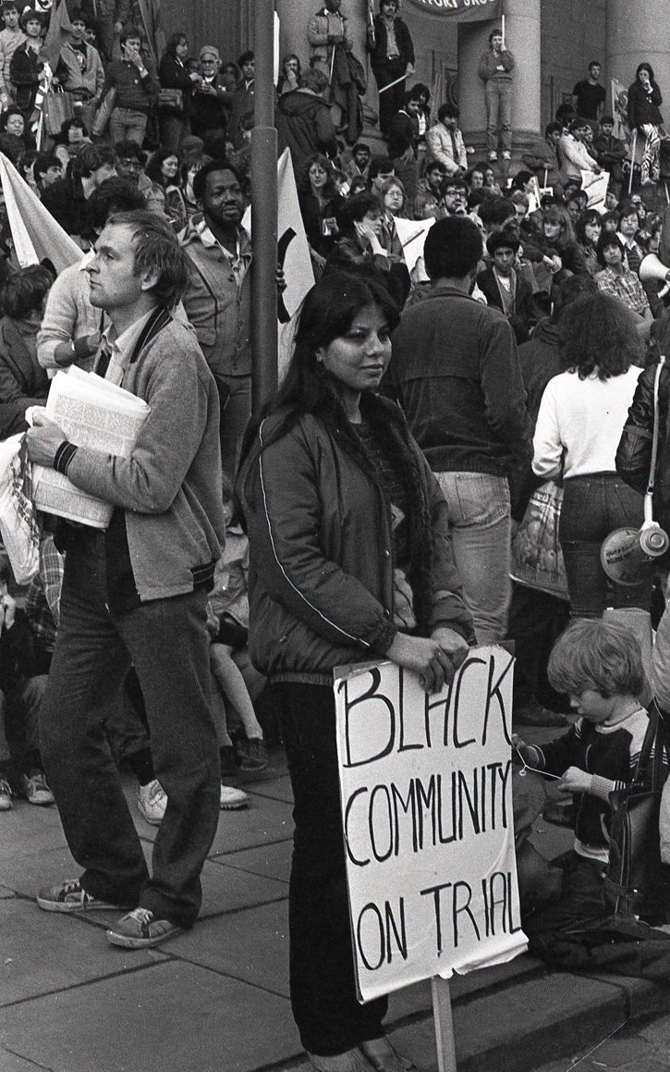
- Free the Bradford 12 demonstration Leeds April 3 1982

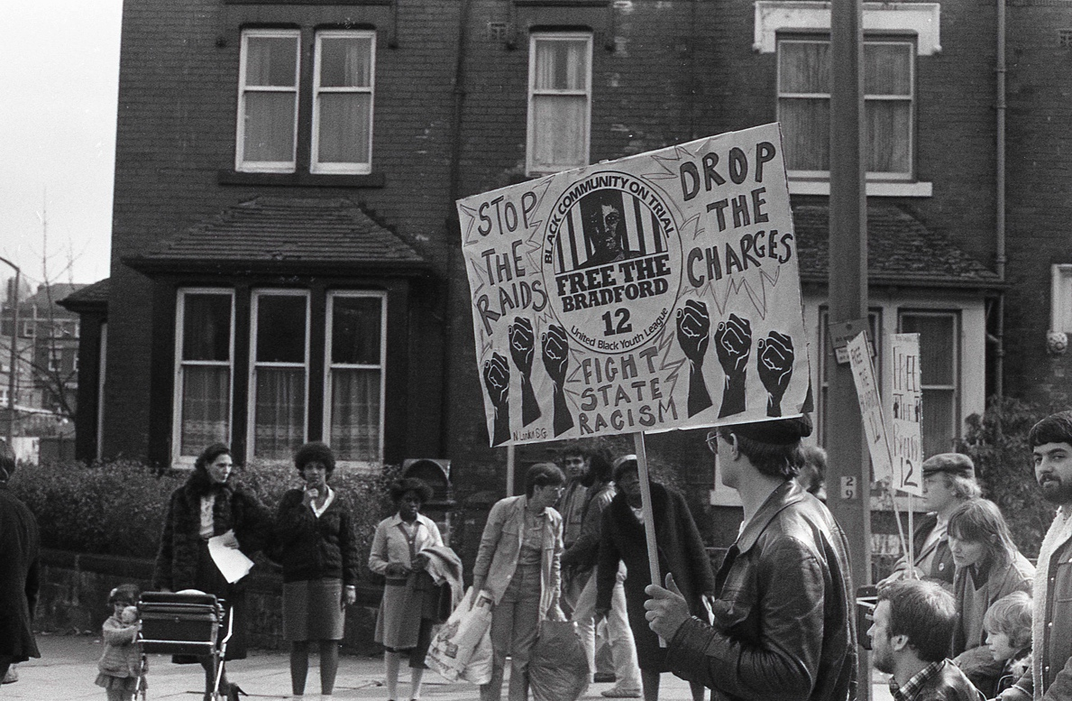
- Free the Bradford 12 demonstration Leeds April 3 1982

